Author: Diana Ciuperca

Date: 16/02/2022

Git repository: https://git.fhict.nl/I505708/individual-assignment-semester-2.git

**Individual project**

Project plan

**Table of Contents**

Introduction ………………………………………………………….…………………………….……. 1

Current Situation ………………………………….……………….……………………………………. 1

Project Goal ………………………………………………………….………………………………….. 1

Deliverables …………………………………………………………………………………………….. 2

Non-Deliverables ……………………………………………………………………………………….. 2

Constraints ……………………………………………………………………………………………… 2

Phasing ………………………………………………………………………………………..………… 3

**Introduction**

This project plan outlines the development of an anime tracker application, which will help users keep track of the anime they are watching, see detailed descriptions and receive notifications for new releases. They are able to create an account in order to discover new anime based on their preferences and customize their own profiles.

**Current Situation**

Currently, there are only a few anime tracker applications available on the market, but many of them are outdated, lack modern features or have a poor user interface. Our goal is to create an anime tracker application that is up-to-date, easy-to-use and accessible to anyone. The application will be available to the public in the form of a website and the maintainers of the website will have access to a desktop application so they could manage the website more efficiently and quicker.

**Project Goal**

The goals of this project include the following:

* Development of an intuitive and user-friendly interface for the anime tracker application.
* Implementation of features such as episode tracking, customizable profile, list making, community reviews etc.
* Delivery of both a website and a desktop application.
* Wide and continuously changing database to provide accurate and up-to-date information on anime titles, episodes, and details.
* The website will be available for anonymous use as well as account registration.
* Testing and bug fixing to ensure the stability and reliability of the application.
* The project will be divided into five phases: analysis, design, implementation, testing and deployment.

**Deliverables (Week 3 intermediate version)**

- Ideation document

- Project Plan

- URS

- Test plan

- UML class diagram

- Desktop application

- Web application

**Non-Deliverables (Week 3 intermediate version)**

- It won’t be delivered any hardware or training as it’s not within the scope and the application will be designed to be used without any prior training.

- Based on the short timeframe allocated, it cannot be expected to deliver a fully functional and polished project. The first submission will be the first version and new features will be continuously added during the 18-week period.

- Local storage for the data.

- There aren’t going to be any manuals for the application because of the limited timeframe of the project.

- There will be no future maintenance, performance improvements or security updates.

**Constraints**

*Time*

* The 3-week timeline may be too tight for a complex software intermediate version.
* The limited timeline can also increase the risk of errors or oversights in the development process, as there may not be enough time for thorough testing, debugging, and refinement.

*Money*

* Budget constraints can impact the quality and functionality of the solution delivered. The budget is limited, so certain features or requirements may need to be scaled back or omitted, potentially reducing the overall value of the solution.
* The limited funds can also impact the resources available to the development team, including the number of developers, quality assurance staff, and equipment.

*Software tools*

* The application is developed in C# and will not be compatible with other programming languages.
* The script for the database will be compatible only with MSSQL.

To overcome these limitations, it's important to have a clear view of the requirements and expectations for the project, prioritize the most important features, and allocate adequate resources and budget to ensure the delivery of a high-quality solution within the given timeframe.

**Phasing (Week 3 intermediate version)**

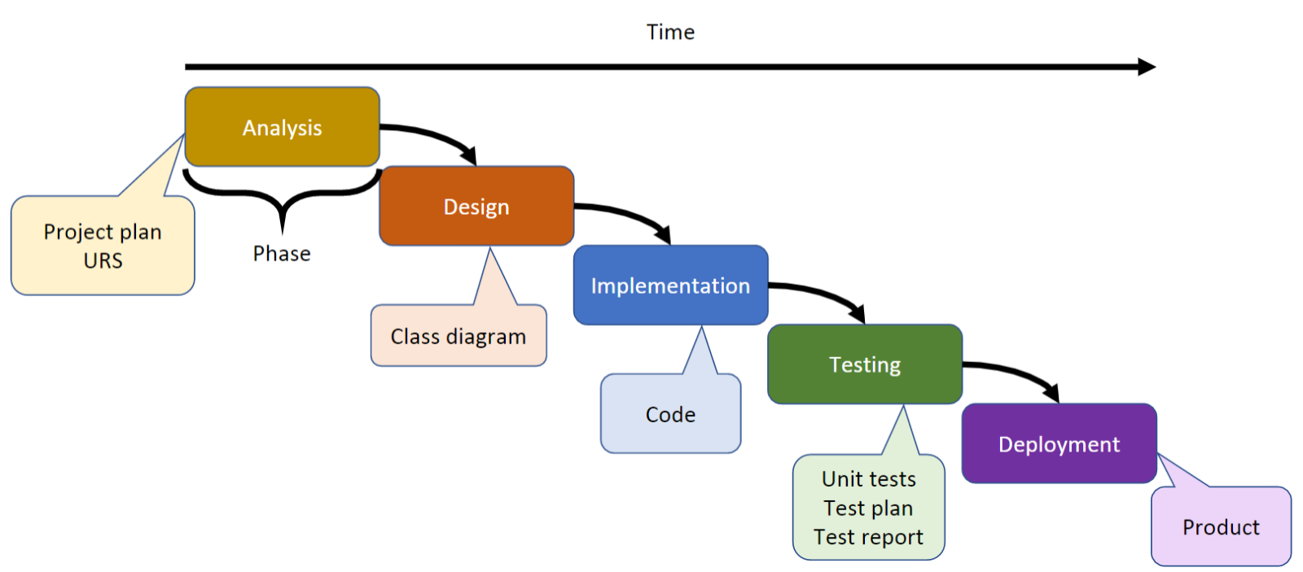

Phase 1: Analysis

* Activities:
* Activity 1.1: Ideation document
* Description: Creation of an explanatory document about the idea of the project
* Estimated time: 3 hours
* Activity 1.2: Project Plan
* Description: Creation of the project plan for the next 3 weeks
* Estimated time: 3 hours
* Activity 1.3: User requirements specifications
* Description: Creation the URS
* Estimated time: 6 hours
* Deliverables:
* Deliverable 1.1: Ideation document
* Deliverable 1.2: Project Plan
* Deliverable 1.3: URS

 Phase 2: Design

* Activities:
* Activity 1.1: Logo creation
* Description: Creation of a representative logo for the anime tracker
* Estimated time: 1 hour
* Activity 1.2: UML class diagram
* Description: Creation of the structure of the classes for the application
* Estimated time: 4 hours
* Activity 1.3: Wireframes and prototype
* Description: Design the first look of the application
* Estimated time: 3 hours
* Deliverables:
* Deliverable 1.1: Logo
* Deliverable 1.2: UML class diagram

Phase 3: Implementation

* Activities:
* Activity 1.1: Desktop application – Content management
* Description: Creation of the management page for the different types of content (anime, manga, characters)
* Estimated time: 8 hours
* Activity 1.2: Desktop application – Login/ Registration
* Description: Creation of the Login/Registration page
* Estimated time: 4 hours
* Activity 1.3: Web application – General design
* Description: Creation of the general look of the website
* Estimated time: 6 hours
* Deliverables:
* Deliverable 1.1: Desktop application (first version)
* Deliverable 1.2: Web application (first version)

Phase 4: Testing

* Activities:
* Activity 1.1: Test plan
* Description: Creation of the planning for the testing phase
* Estimated time: 4 hours
* Activity 1.2: Test report
* Description: Documentation of the feedback received after the testing phase
* Estimated time: 4 hours
* Deliverables:
* Deliverable 1.1: Test plan
* Deliverable 1.2: Test report

Phase 5: Deployment

* Activities:
* Activity 1.1: Improve UI
* Description: Addition of visual elements regarding the final version of both the web and desktop applications
* Estimated time: 6 hours
* Activity 1.2: Project report
* Description: Documentation of the entire process of creation
* Estimated time: 4 hours
* Deliverables:
* Deliverable 1.1: Desktop application (final version)
* Deliverable 1.2: Web application (final version)
* Deliverable 1.3: Database script (final version)
* Deliverable 1.4: Project report